Al Imam Mohammad Ibn Saud Islamic University
College of Computer and Information Sciences Information SystemsDepartment

Course Title: Systems Analysis and Design
Course Code: | IS 1235
Academic Year: | 2nd semester 2025-26

Project Title: | Restaurant Order Management System

1. Introduction
improve operational efficiency and service quality. Traditional manual systems for managing orders often result in delays, order inaccuracies, and miscommunication between staff members such as waiters, chefs, and cashiers.
In recent years, the restaurant industry has increasingly adopted digital solutions to This project introduces a Restaurant Order Management System, designed to automate and streamline the process of handling customer orders, managing menu items, processing payments, and facilitating communication between different staff roles within the restaurant. The system aims to replace manual workflows with an integrated digital solution that enhances accuracy, reduces errors, and improves overall customer satisfaction.
By implementing this system, restaurants can provide faster service, ensure better coordination among staff, and deliver a more reliable and efficient dining experience.

1.1 Project Overview

The Restaurant Order Management System is a centralized platform that supports the core operations of a restaurant by connecting all users within a single system. The system is designed to handle multiple roles, each with specific functionalities to ensure a smooth and efficient workflow.

The system enables:

- Waiters to create and manage customer orders, check menu availability, add special instructions, and request bills.
- Chefs to view incoming orders and update the order status accordingly.
- Cashiers to process payments, apply discounts, and generate receipts.
- Managers to manage menu items, maintain staff accounts, and monitor sales reports.

Additionally, the system provides features such as real-time updates, order tracking, and internal notifications between staff members. These features help reduce delays, improve communication, and ensure that orders are processed efficiently.
Overall, the system enhances restaurant performance by improving accuracy, reducing manual effort, and ensuring seamless coordination between all roles.

1.2 Problem Description

The main problem in many restaurants today is that they still use paper and pens to manage everything. the way a local order moves from the table to the kitchen and then to the cashier is often slow and full of mistakes:

- Mistakes from Handwriting: Writing orders on paper slips often leads to human error; if the handwriting is messy or unclear, the kitchen might prepare the wrong meal.

- Lack of Order Tracking: Without a digital system, waiters cannot see how the food is progressing in the kitchen. They have to keep walking back and forth to ask the chef if the food is ready, which wastes time.

- Confusion Over Menu Availability: In a manual system, waiters do not know immediately if an item is finished. This leads to the awkward situation where a waiter takes an order and then has to come back later to tell the customer that the meal is out of stock.

- Forgetting Special Requests: Local customers often ask for special things, like no onions or extra sauce. On paper, these important notes are easily lost or forgotten when the waiter gives the slip to the chef.

- Slow Billing at the End: When it is time to pay, calculating the total and adding discounts by hand is very slow and can lead to money mistakes. This makes customers wait too long at the cashier desk before they leave.

All these daily problems make the work very stressful for the staff and create a slow experience for the guests. Our Restaurant Order Management System is built to solve this by making everything digitizing all processes.

2. Methodology

2.1 Project Lifecycle: SDLC Selection & Justification

For this project, the Agile methodology was selected as the Software Development Life Cycle (SDLC) approach due to its flexibility and adaptability.

Agile is an iterative development methodology that focuses on delivering the system in small, manageable increments while continuously improving based on feedback.

Flexibility and Adaptability:
The requirements of a restaurant system may evolve over time, such as adding new features like discounts or notifications. Agile allows these changes to be incorporated without disrupting the entire system.

Incremental Development:
The system can be developed in smaller modules, such as order management, payment processing, and reporting. This makes the development process more structured and easier to manage.

Improved Team Collaboration:
Agile promotes continuous communication among team members, which is essential in group projects to ensure consistency and proper integration between different components.

Early Testing and Continuous Feedback:
Each iteration can be tested early, allowing issues to be identified and resolved quickly, resulting in a higher-quality system.

User-Centered Design:
The system is built around different user roles (Waiter, Chef, Cashier, Manager), and Agile supports refining the system based on user interaction and feedback.

Agile is the most suitable methodology for this project because it supports flexibility, continuous improvement, and effective teamwork, resulting in a reliable and userfriendly Restaurant Order Management System.

3. System Analysis

3.1Requirements Definition

Requirements definition is a fundamental phase in the systems analysis process. It involves identifying, documenting, and organizing the needs and expectations of all stakeholders to ensure the system delivers the intended functionality.
For the Restaurant Order Management System, requirements were gathered by analysing the problems faced by restaurant staff and identifying the key operations the system must support.
The requirements are divided into two categories: functional requirements, which describe what the system must do, and non-functional requirements, which describe how well the system must perform.

3.1.1Functional Requirements

The system shall allow the Waiter to place orders
The system shall allow the Waiter to manage orders
The system shall allow the Waiter to request bill
The system shall allow the Waiter to receive order notification The system shall allow the Chef to receive orders.
The system shall allow the Chef to update order status.
The system shall allow the Chef to notify waiter The system shall allow the Cashier to process payments.
The system shall allow the Cashier to apply discounts.
The system shall allow the Manager to manage menu items .
The system shall allow the Manager to manage staff accounts.
The system shall allow the Manager to view sales reports.
The system shall interact with the bank to process payment
The system shall allow all users to login to their specific dashboards

3.1.2Non Functional Requirements

The system shall be function efficiently on a local wireless network to ensure constant communication between the waiter and the kitchen.

The system shall be secure by restricting data access levels based on assigned user roles.

The system shall be available with a minimum uptime of 99.9% during operational hours.

The system shall be usable, requiring a maximum of 30 minutes for new staff orientation.

The system shall be ensure 100% accuracy in all automated price and tax calculations.

The system shall be provide a multi-language interface.

The system shall be ensure data integrity by preventing data loss during unexpected hardware failures.

The system shall be able to recover and restart within 5 minutes after a system crash.

The system shall be capable of storing up to 5 years of historical sales data for reporting purposes.

3.2 Functional Business Process Modeling

3.2.1 Level 0 DFD

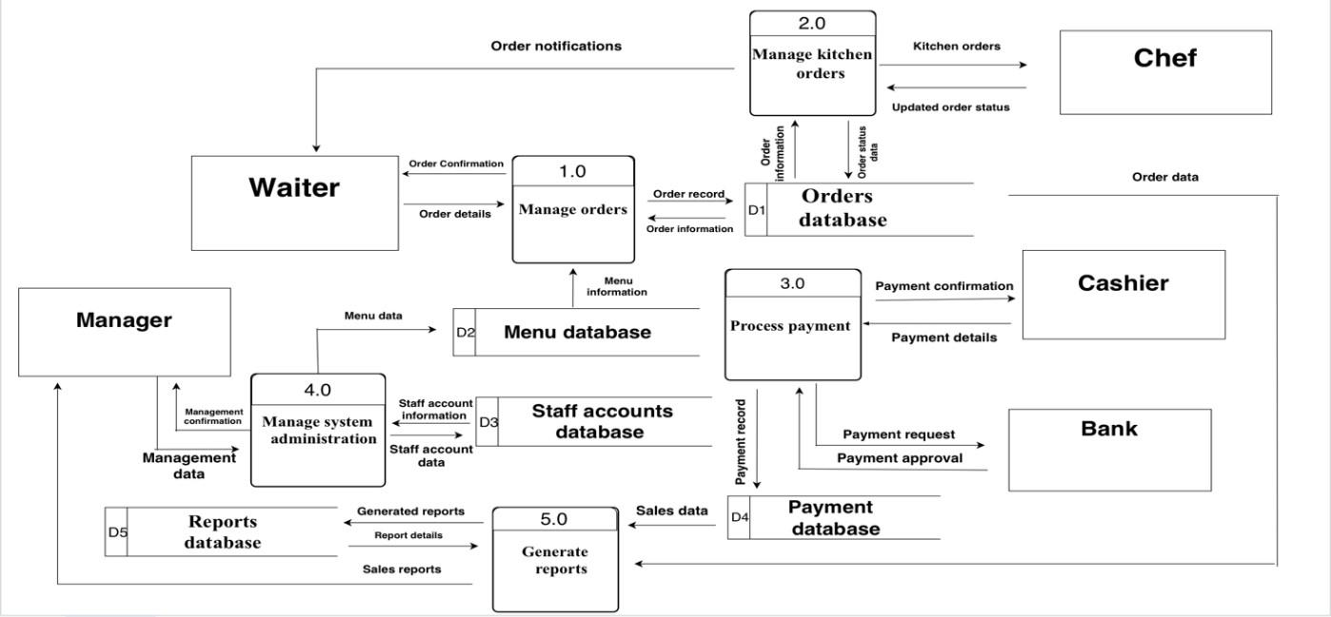

3.2.2 BPMN Diagram

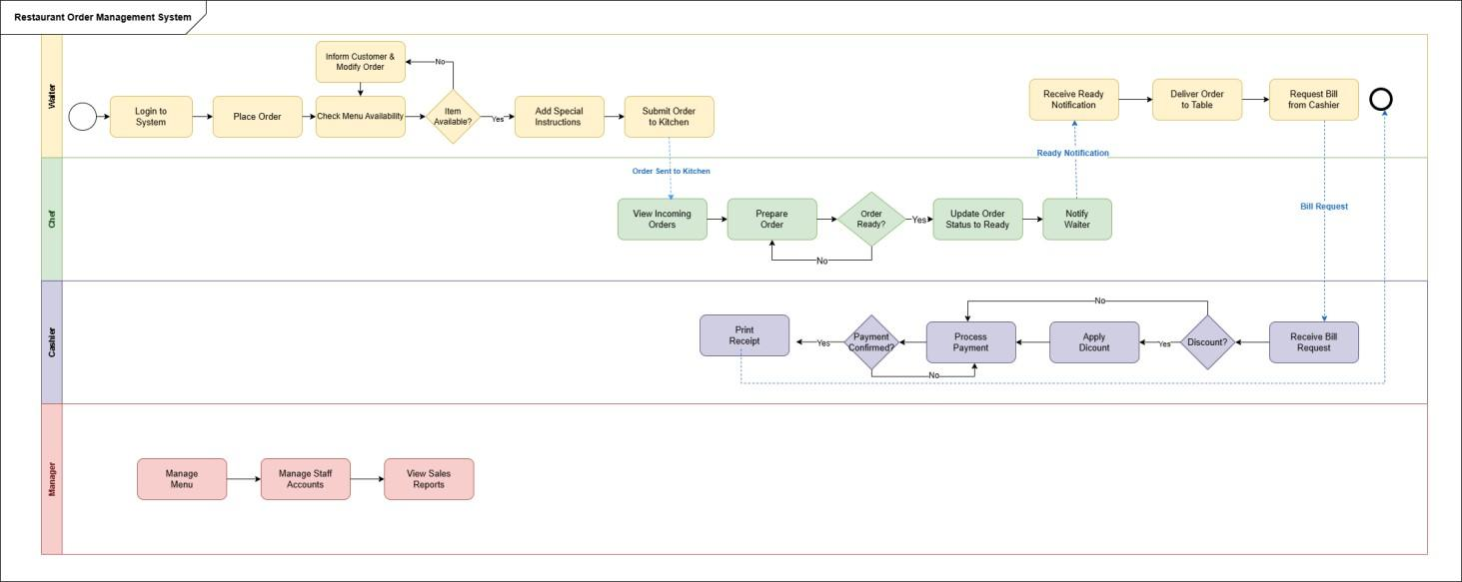

3.2.3 Use Case Diagram

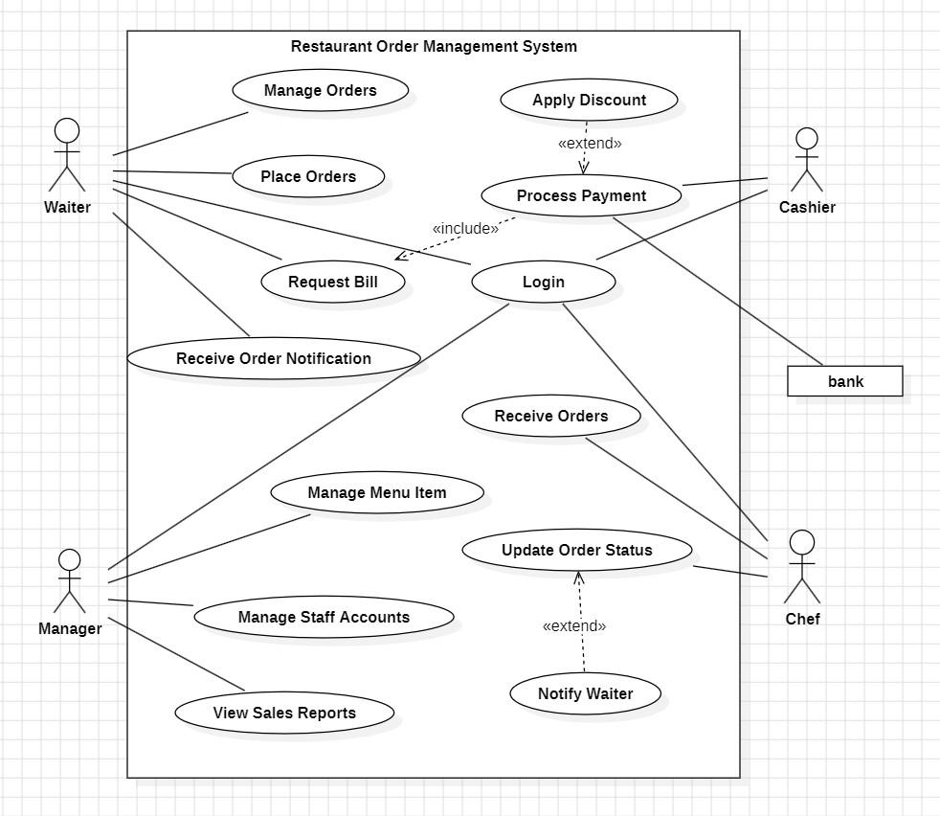

3.2.4 Use Case Description
Table: Use Case Description – Manage Order
Use Case  Name | Manage Order
Use Case ID | UC-01
Actor(s) | Waiter (Primary), Chef (Secondary), Cashier (Secondary)
Description | This use case describes the full process of managing a customer order, from the moment the Waiter records the order in the system, through kitchen preparation by the Chef, to final payment processing by the Cashier.
Preconditions | - The Waiter is logged into the system.  - The customer is seated at a table.  - The menu is available and up to date in the system.
Postconditions | - The order is saved in the system with a unique Order ID.  - The Chef has prepared and delivered the order.  - Payment has been processed and a receipt has been issued.
Trigger | The customer informs the Waiter that they are ready to order.
Normal Flow
Step | Description
1 | The Waiter opens the Order Management screen and selects the customer's table number.
2 | The Waiter browses the digital menu and selects the items requested by the customer.
3 | The system checks and displays the availability status of each selected item in real time.
4 | The Waiter adds any special instructions provided by the customer (e.g., no onions, extra sauce).
5 | The Waiter confirms and submits the order to the kitchen.
6 | The system assigns a unique Order ID, saves the order, and sets its status to Pending.
7 | The Chef receives and views the new order on the kitchen screen.
8 | The Chef prepares the order and updates the status to Ready.
9 | The system notifies the Waiter that the order is ready.
10 | The Waiter delivers the order to the customer's table.
11 | The Waiter requests the bill from the Cashier.
12 | The Cashier calculates the total amount and processes the payment.
13 | The Cashier prints the receipt and the Waiter delivers it to the customer.
Subflows
Subflow 1: Menu Item Unavailable
S1-1 | At Step 3, the system identifies that a selected item is unavailable.
S1-2 | The system highlights the unavailable item on the screen.
S1-3 | The Waiter informs the customer and removes or replaces the item.
S1-4 | The use case resumes from Step 2.
Subflow 2: Apply Discount
S2-1 | At Step 12, the Cashier checks if a discount is applicable to the order.
S2-2 | If a discount applies, the Cashier enters the discount amount into the system.
S2-3 | The system recalculates the total and applies the discount before processing payment.

3.2.5 Activity diagram
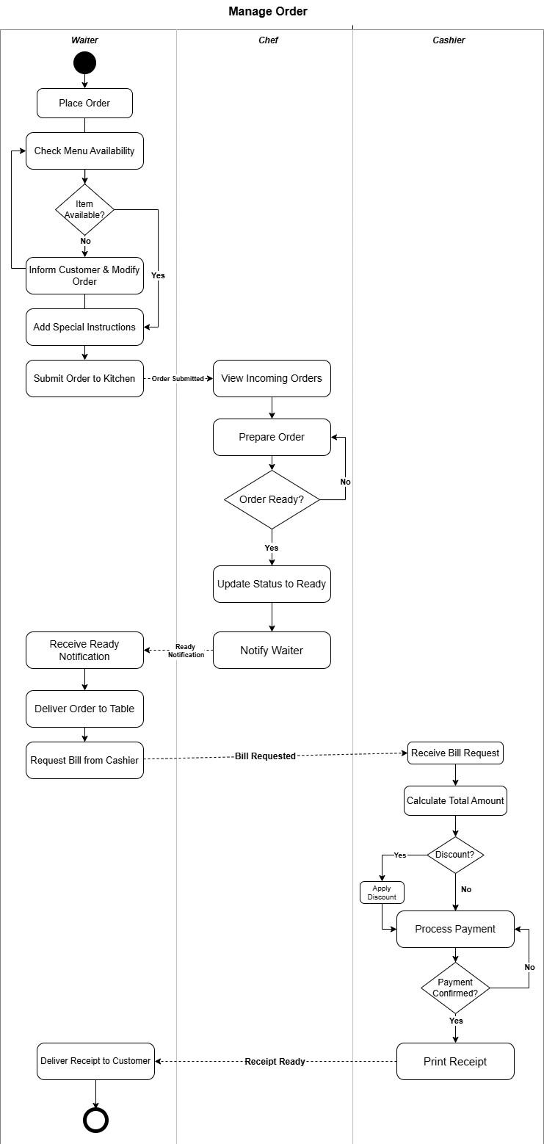

3.3 Structural Modeling

3.3.1 Class Diagram

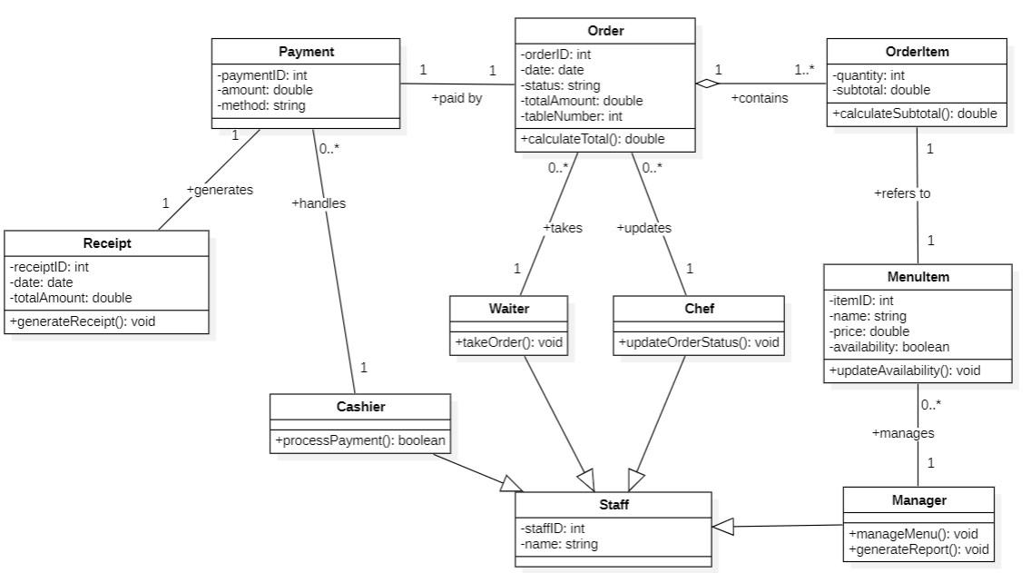

3.3.2 CRC Cards

 | Class Name: Order | ID: 1 |  | Type: Concrete, Domain
 | Description:  The Order class represents a restaurant order created and managed by the waiter within the Restaurant Order Management System.  It stores essential order details such as the order date, status, total amount, and table number.  The class is responsible for managing the lifecycle of an order, from creation to completion, including tracking updates and coordinating with staff and payment processing. |  |  | Associated Use Cases: 3
 | Responsibilities:  - Manage restaurant orders created by the waiter  - Track and update the status of each order  - Calculate the total amount based on order items  - Store order details such as date, status, and table number  - Ensure accuracy and consistency of order information |  | Collaborators:  - OrderItem  - Payment  - Waiter  - Chef  - Cashier
Attributes:

OrderID: int
Date: date
Status: string
TotalAmount: double
TableNumber: int

Relationships:

Generalization (a-kind-of): None

Aggregation (has-parts): OrderItem

Other Associations: Payment, Waiter, Chef, Cashier

3.3.3 Object Diagram

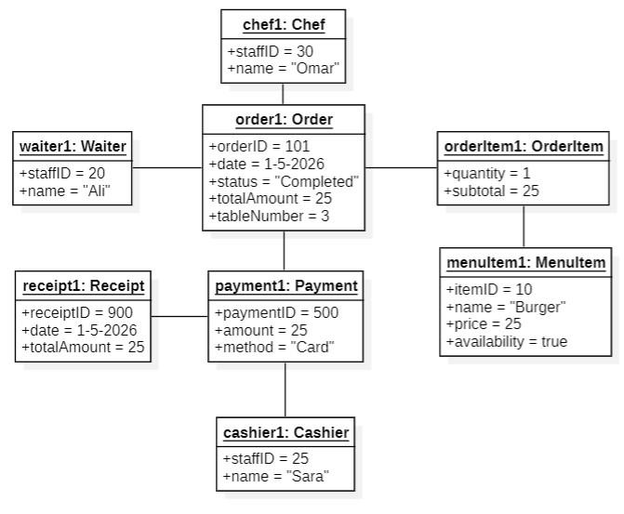

3.4 Behavioral Modeling

3.4.1 Sequence Diagram

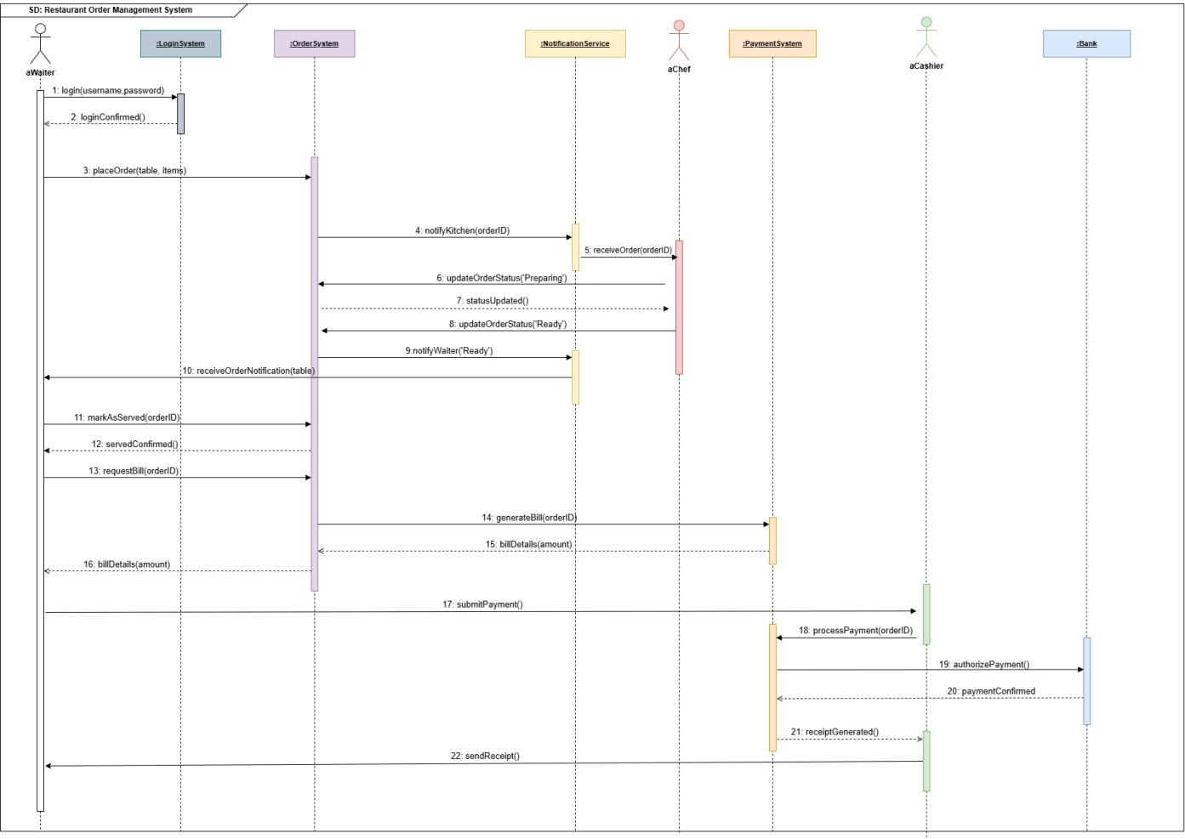

3.4.2 Behavioral State Machine

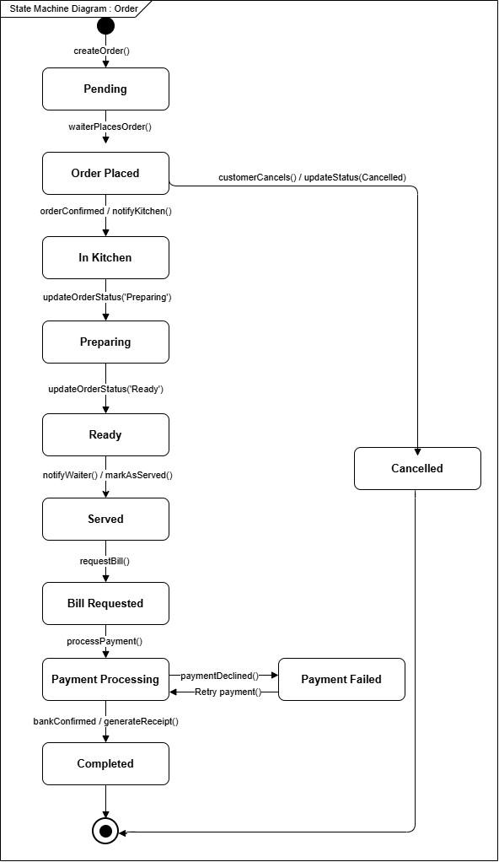

- System Design
4.1 User Interface Design

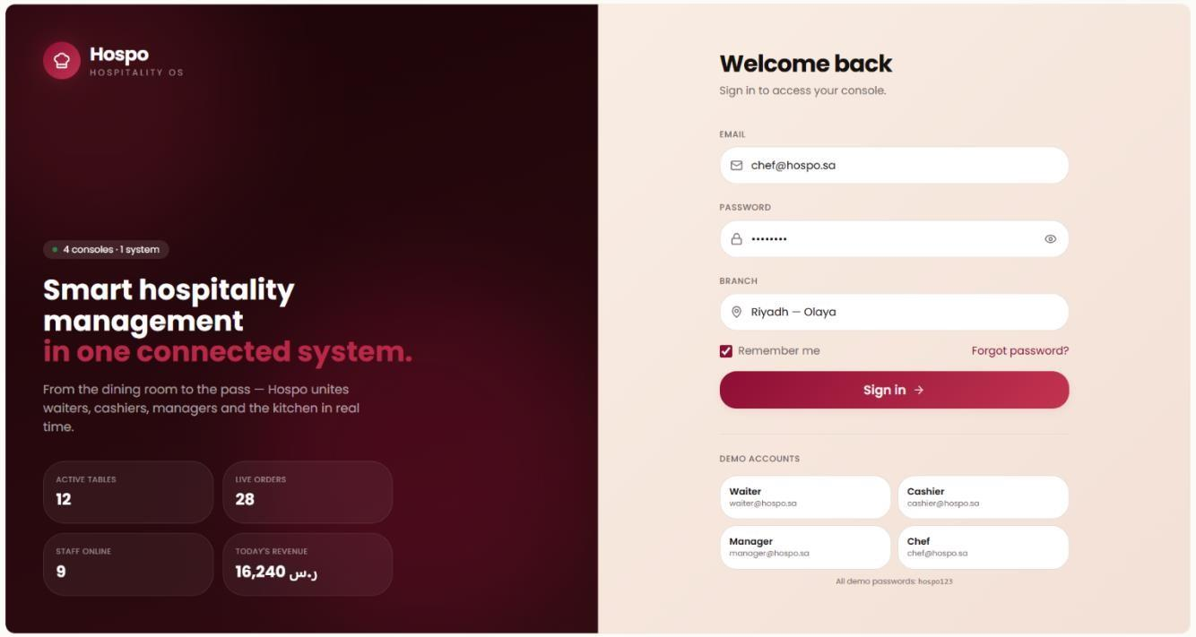

Login Interface
Allows staff members to securely access the system based on their roles

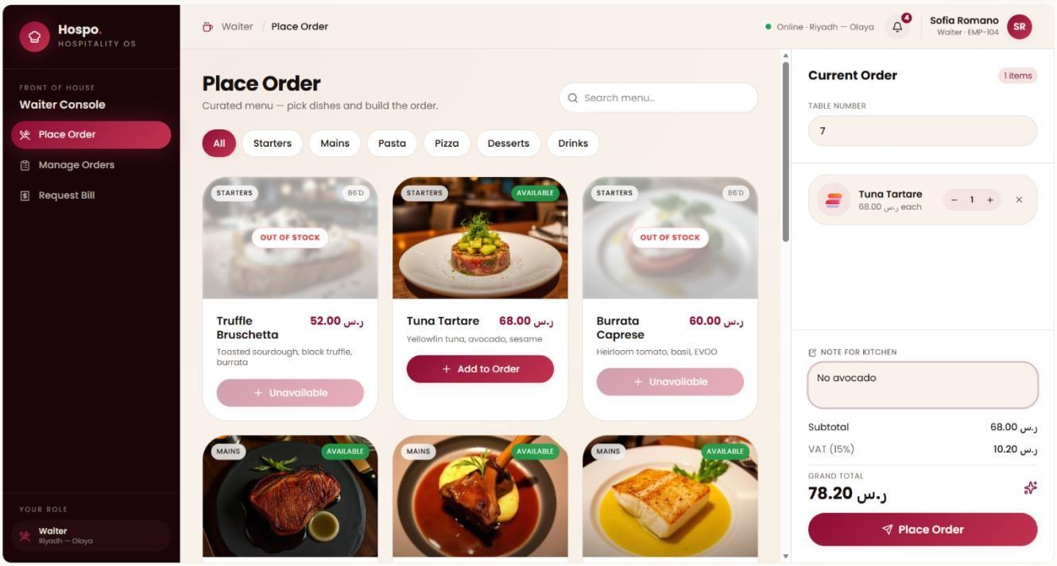

Waiter Interface
Enables waiters to place customer orders and send notes to the kitchen.

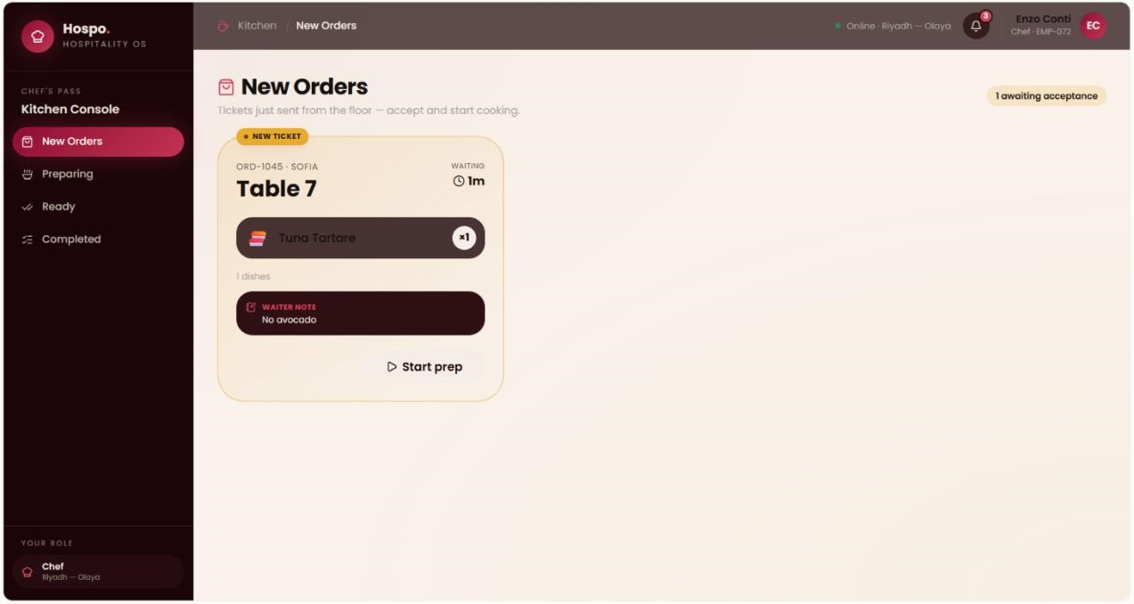

Chef Interface
Displays incoming orders and kitchen notes while allowing chefs to update order status.

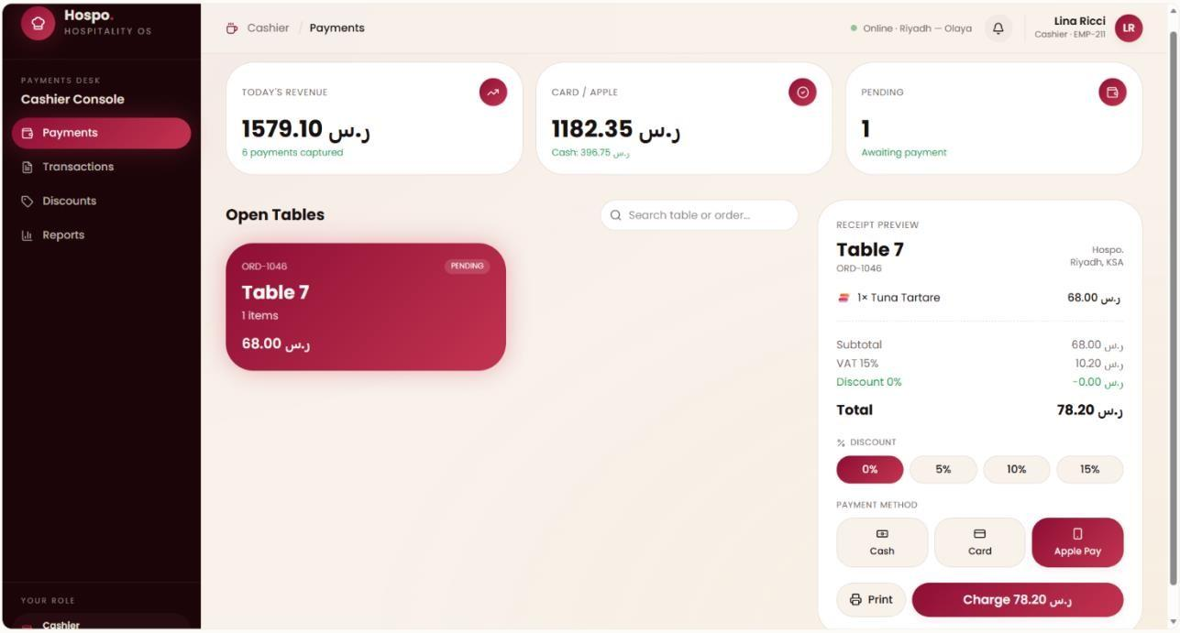

Cashier Interface
Supports payment processing, discounts, and receipt generation.

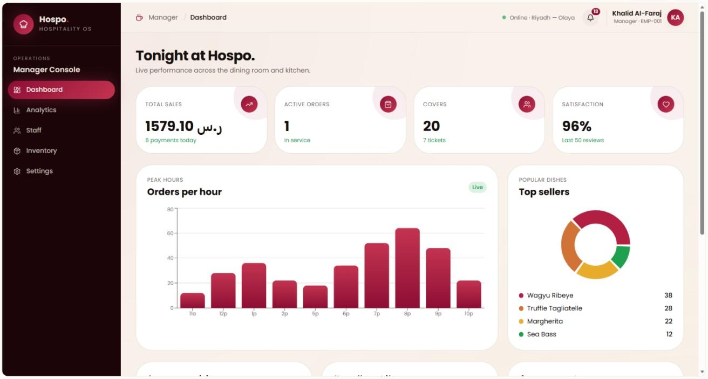

4.2 Deployment Diagram

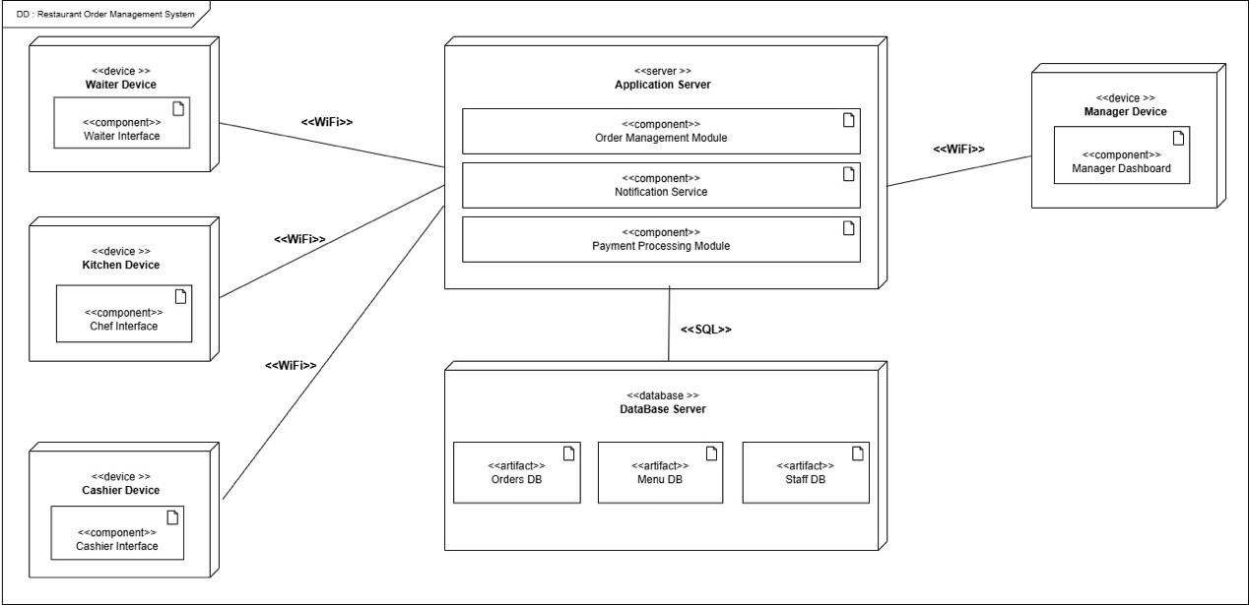

Conclusion

The Restaurant Order Management System successfully addresses the operational challenges of traditional manual workflows by introducing a centralized digital platform. The analysis concludes that transitioning from paper-based systems to an automated solution significantly reduces human errors—such as handwriting mistakes and forgotten special requests—while enhancing communication between the Waiter, Chef, and Cashier. By implementing features like real-time order tracking and automated billing, the system ensures a faster, more reliable dining experience and improves overall restaurant performance and customer satisfaction.
Importance to Educational Practice
The major findings of this project contribute to educational practice in the following ways:
- Application of Agile Methodology: The study demonstrates the practical benefits of using Agile methodology in a structured environment, showing how iterative development allows for flexibility and continuous improvement based on feedback.
- Mastery of System Modeling: The project highlights the importance of translating real-world business problems into technical models, such as Use Case Descriptions, Class Diagrams, and BPMN Diagrams, which are essential skills in systems analysis and design.
- Collaborative Learning: It emphasizes the significance of team coordination and role distribution in accomplishing complex technical tasks effectively and equally within a group setting.
- Requirement Engineering: The findings show how identifying both functional and non-functional requirements is fundamental to ensuring a system meets the specific needs and performance standards of its stakeholders.

References
draw.io (2026). Diagram Software.
Retrieved from https://www.diagrams.net

Figma (2026). Design Tool.
Retrieved from https://www.figma.com

UI Design:
https://share.google/bI2cbhd9kZhpY7jaX

